PRAGNYA Y S

[pragns@deloitte.com](mailto:pragns@deloitte.com)

**ANALYTICS MAJOR ASSIGNMENT**

**Connection with Snowflake**

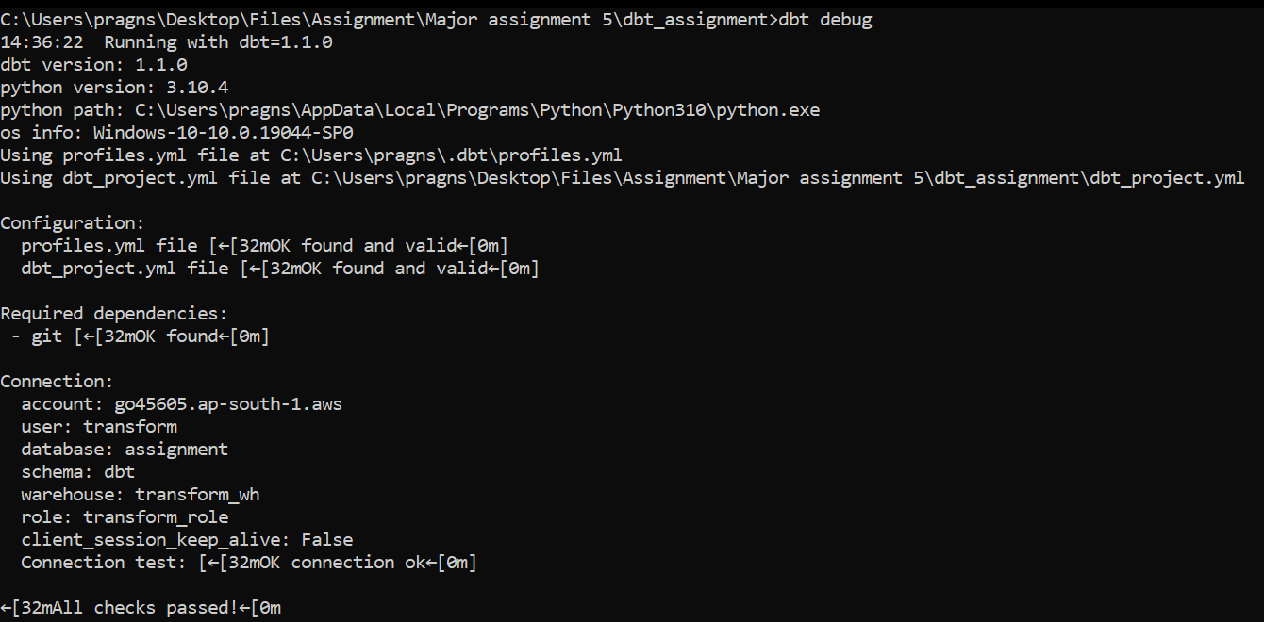

**MILESTONE 1**

1. CalculateMonthly average NAV, Repurchase & Sale Price for each scheme.

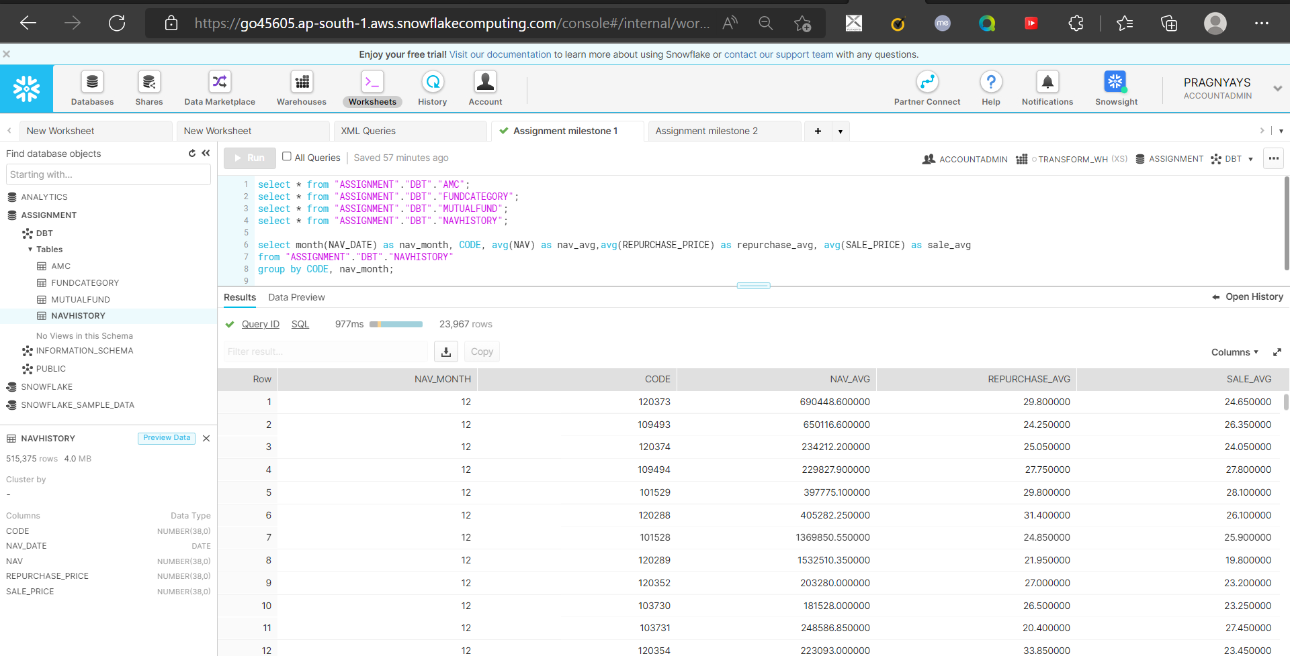

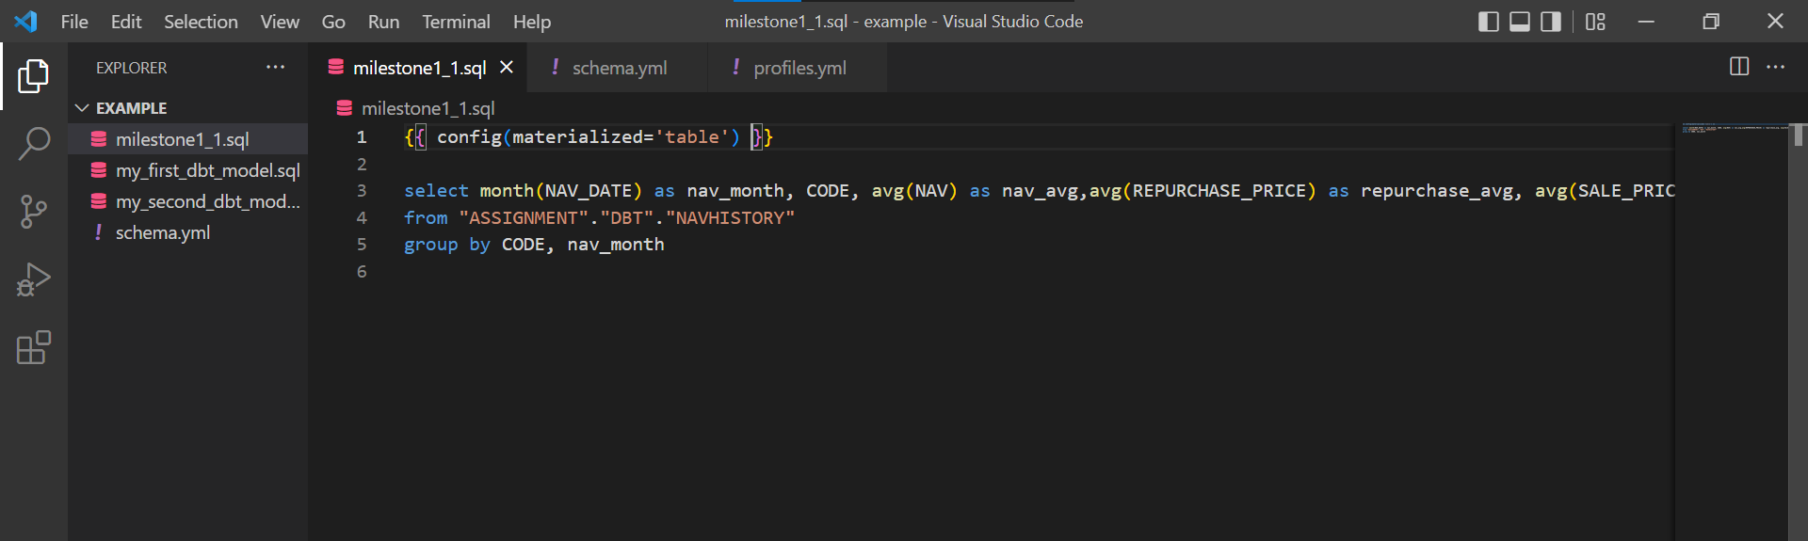

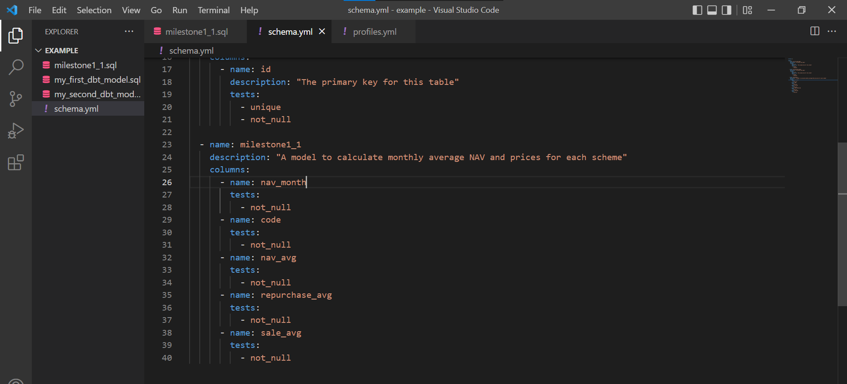

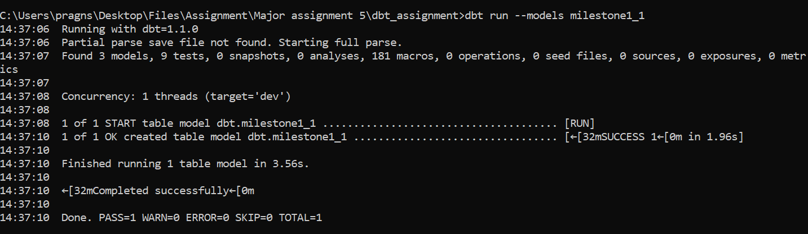

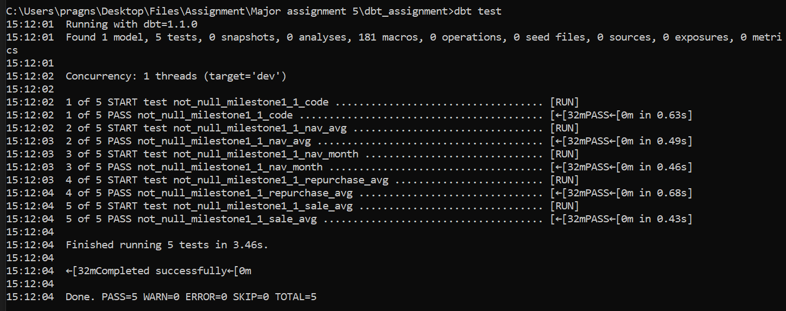

1. Findout each scheme’s Max and Min NAV value and Date it occurred

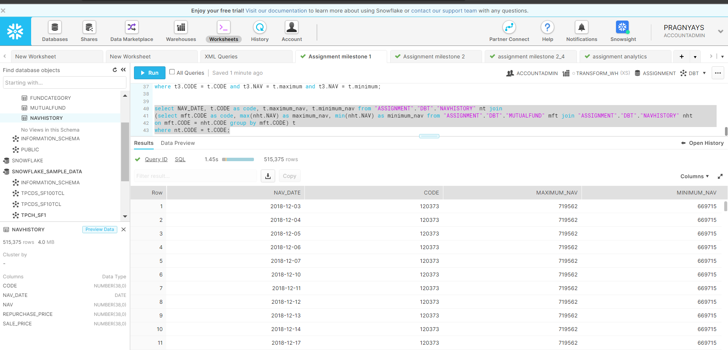

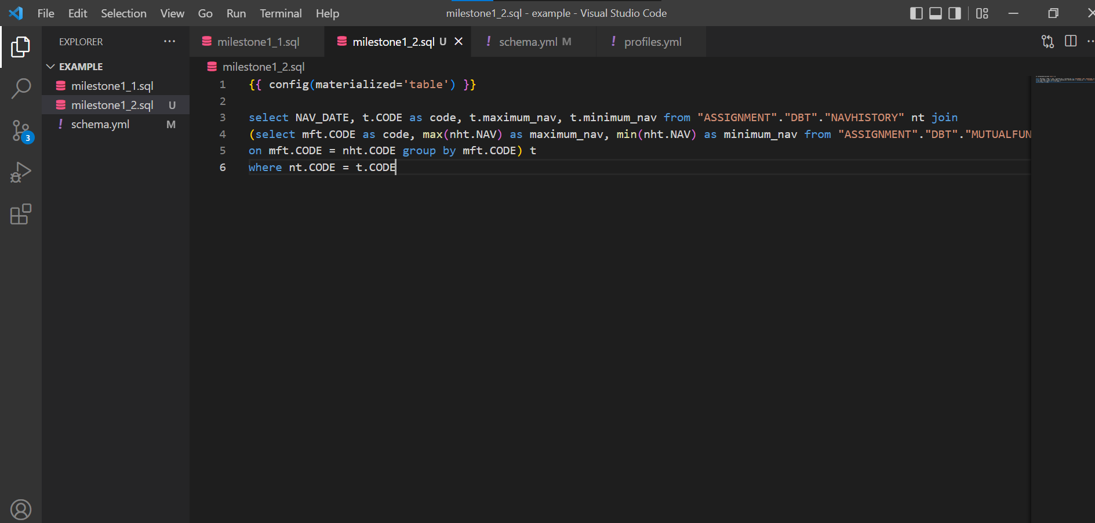

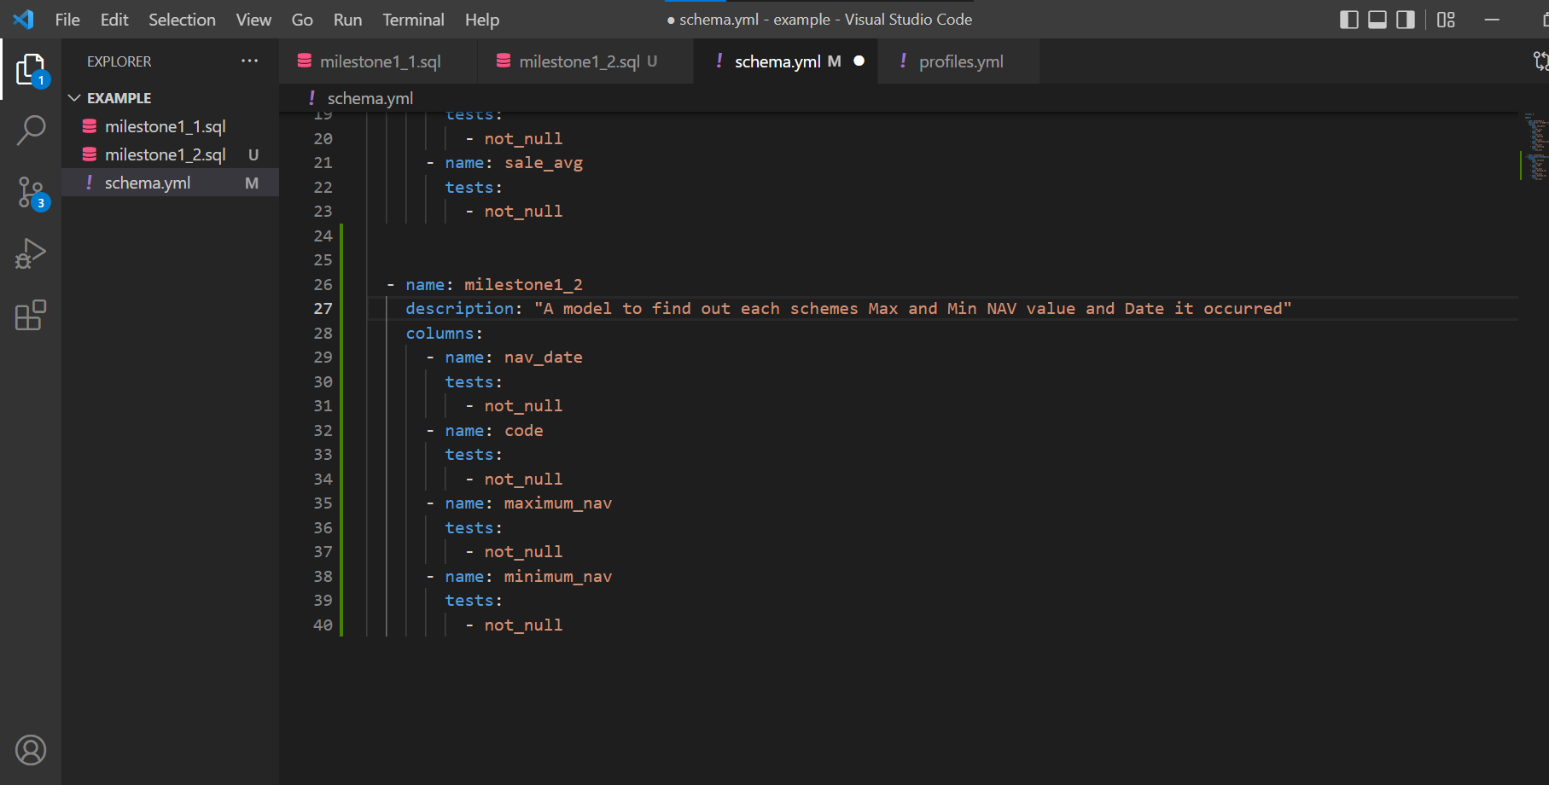

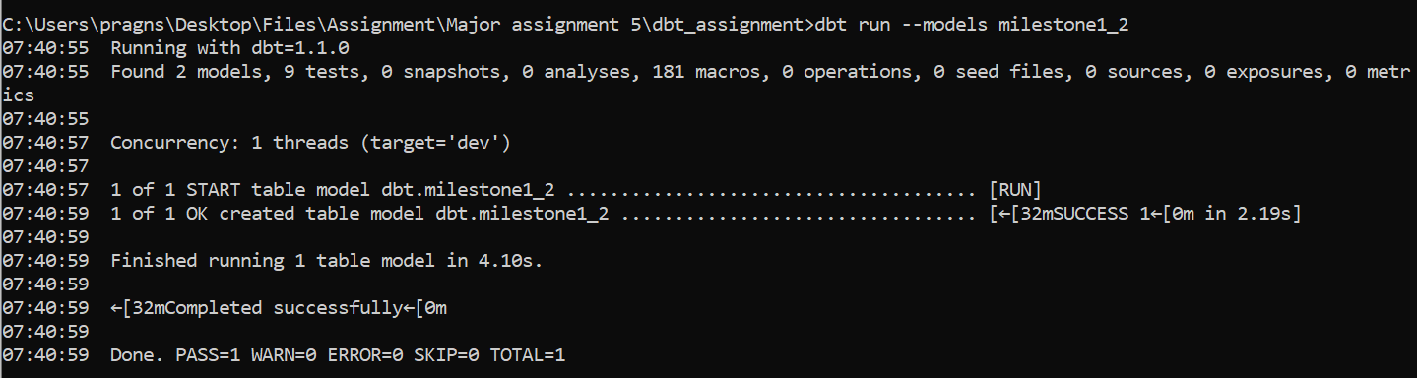

**MILESTONE 2**



Simple: Mutual fund performance - including YTD, MTD, 1 Year and Since Inception returns. See the PPT for formula to calculate this

**YTD returns ->**

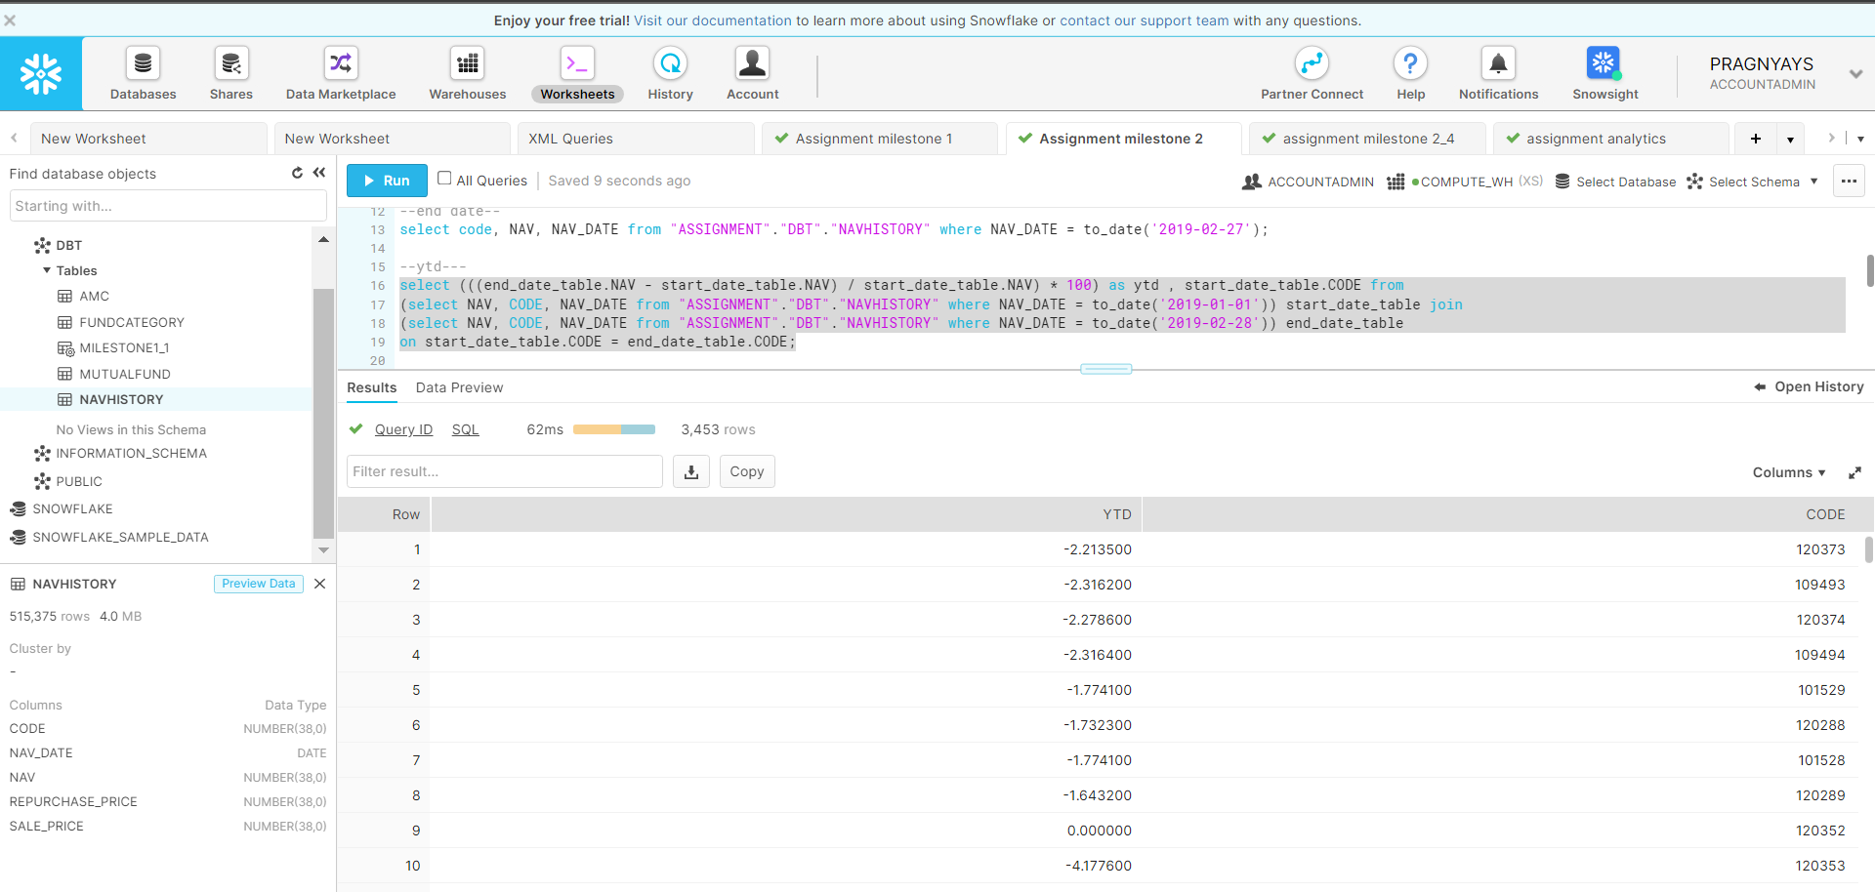

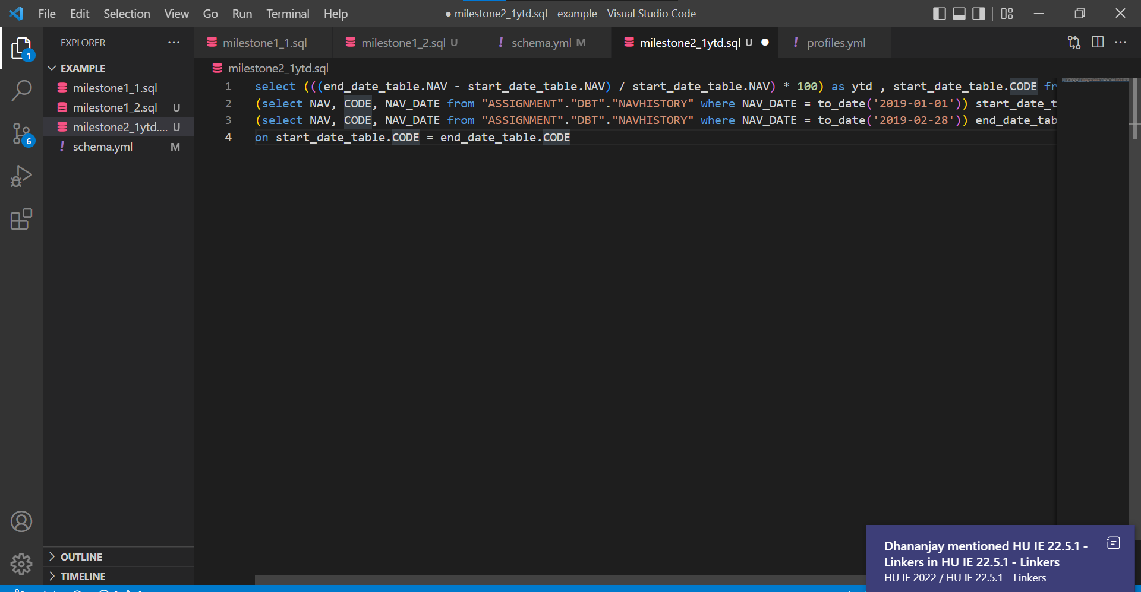

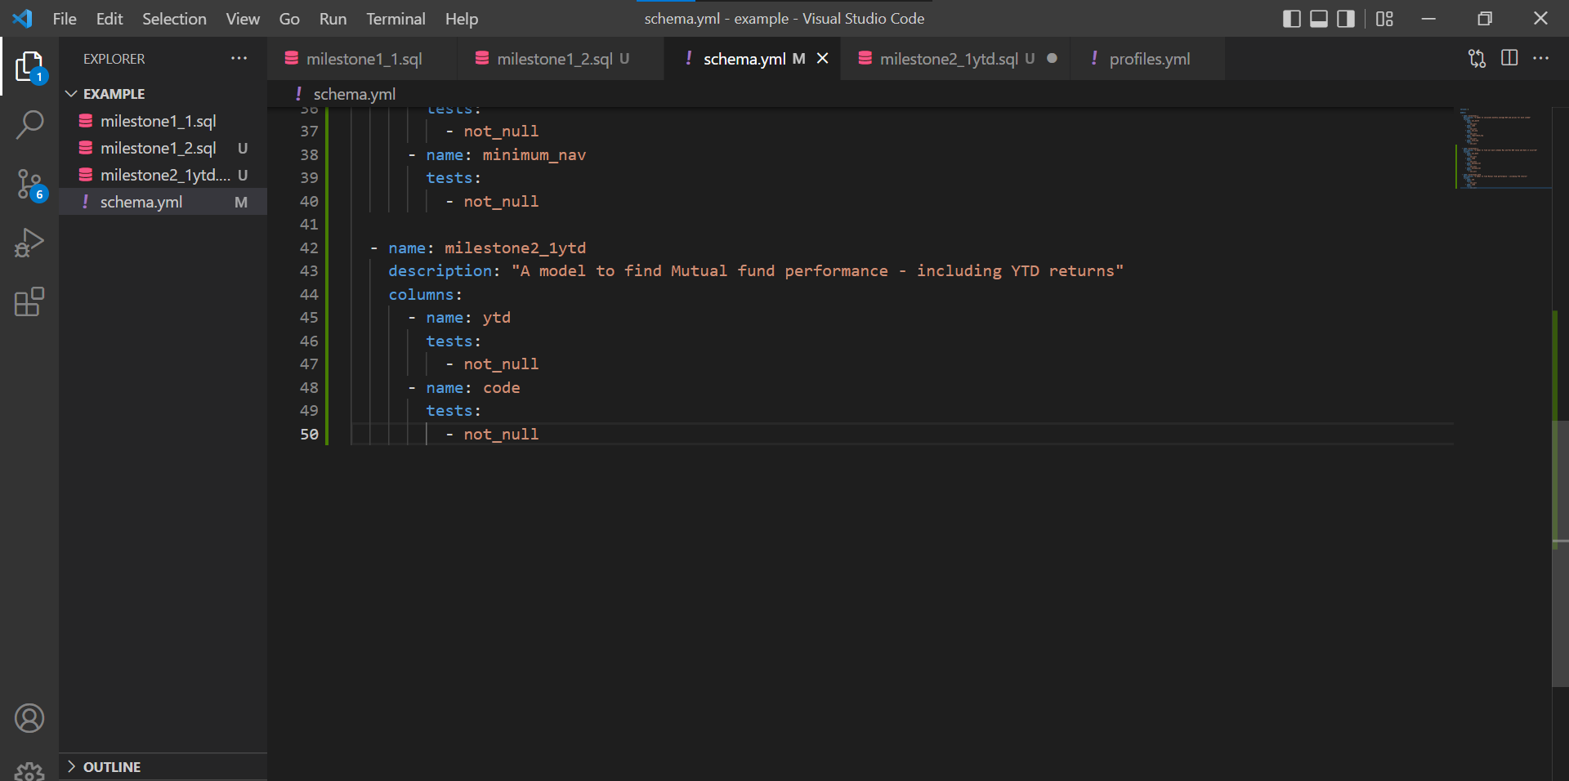

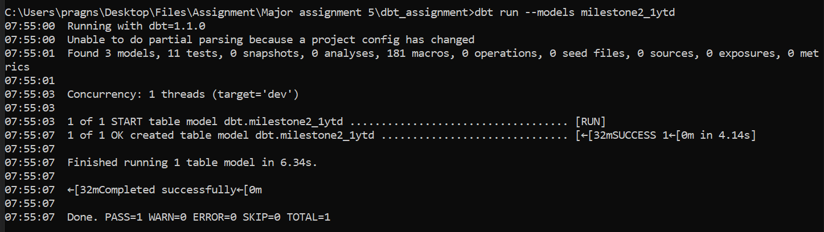

**MTD returns ->**

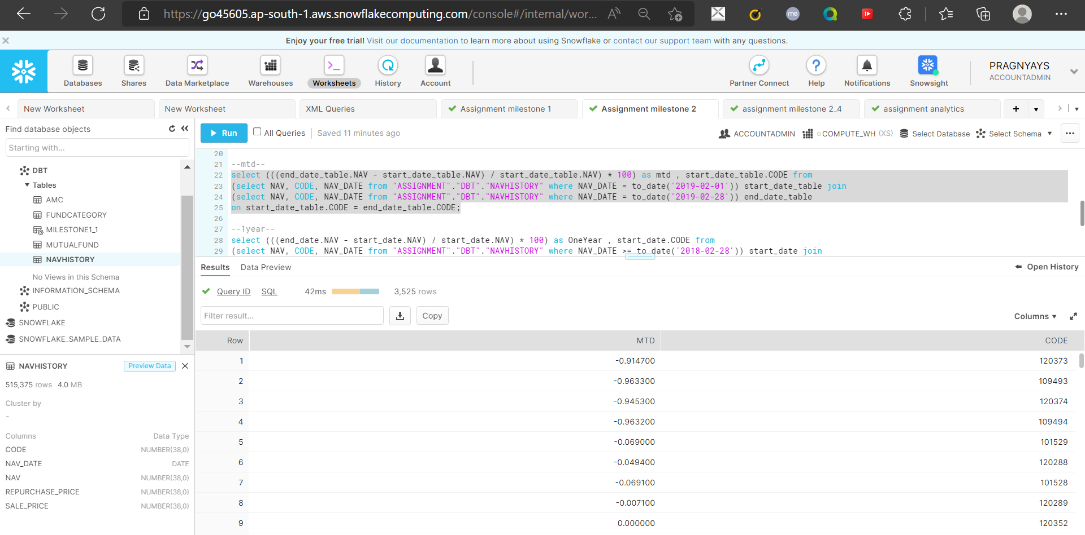

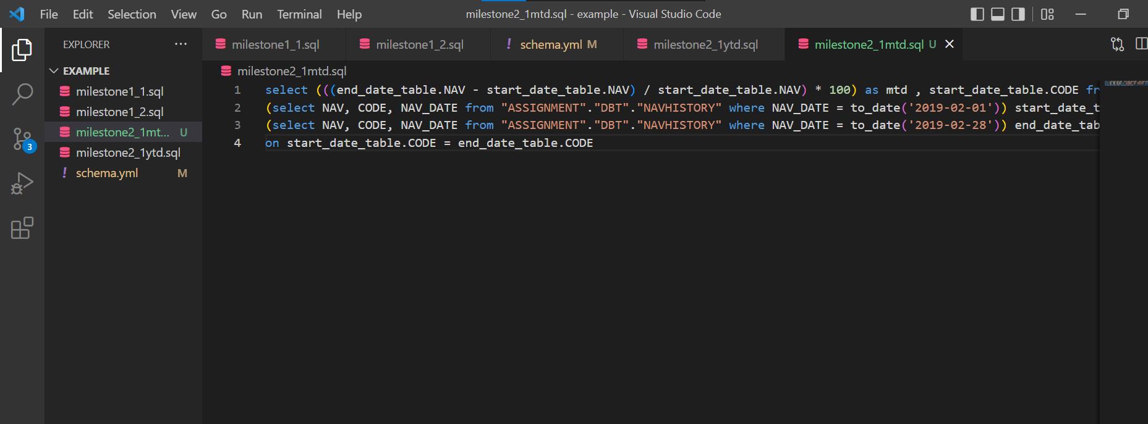

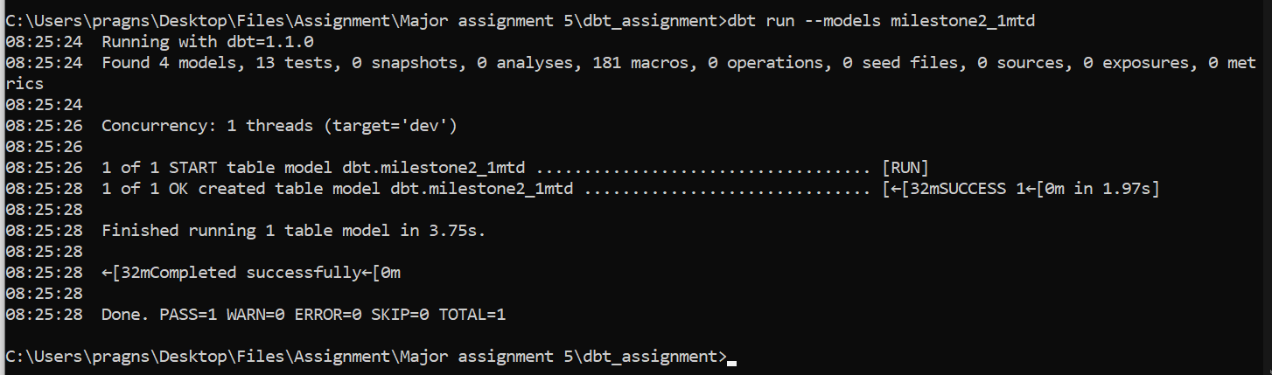

**One Year returns ->**

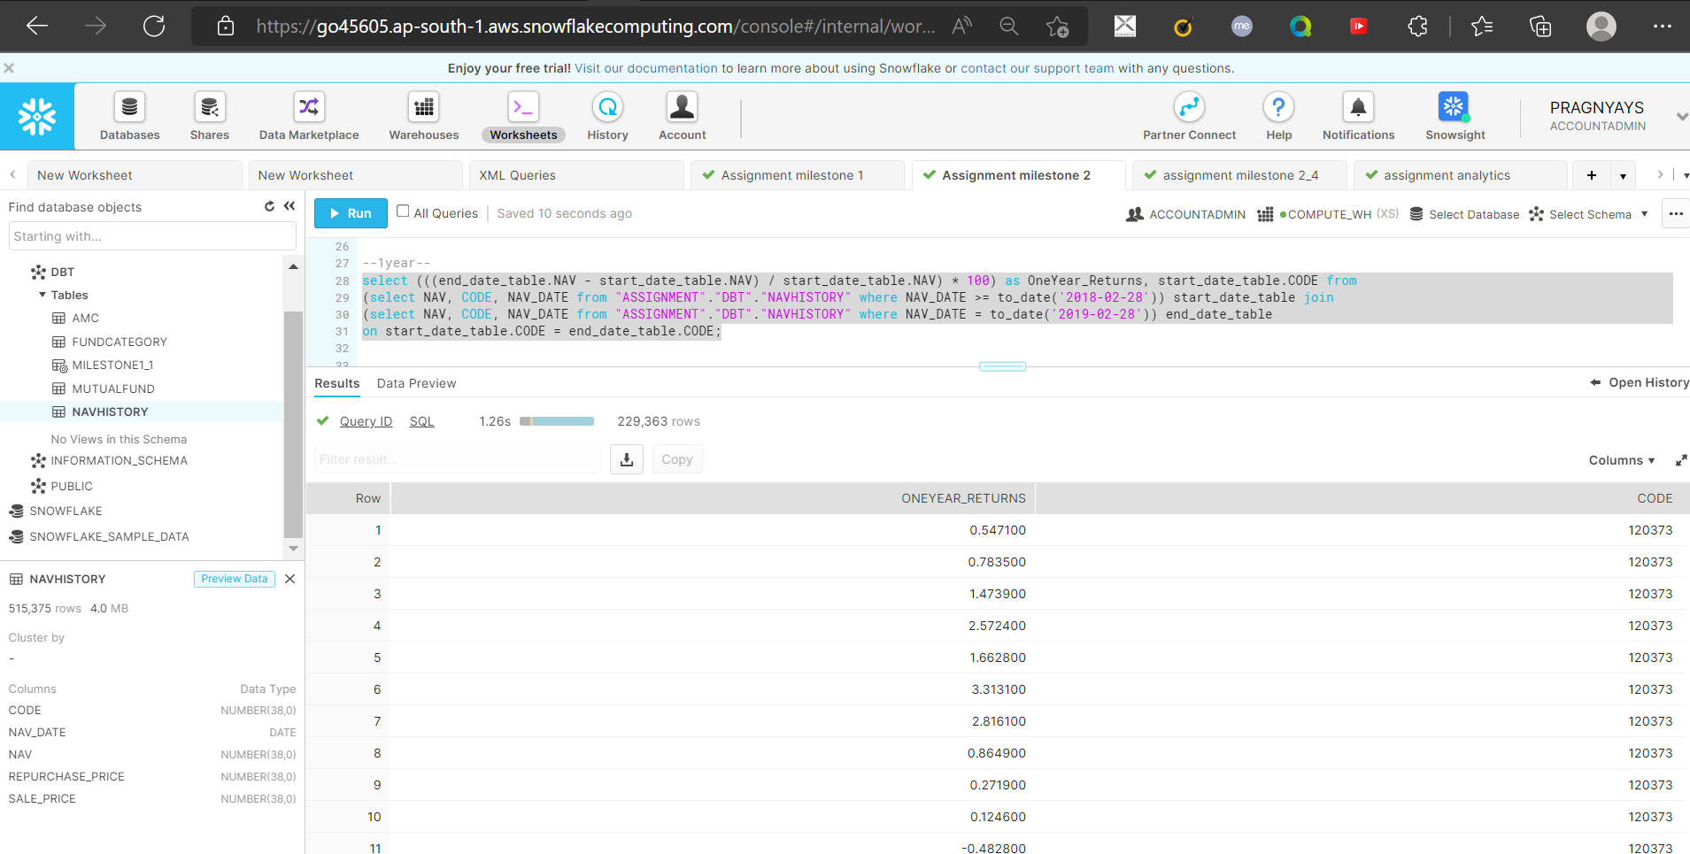

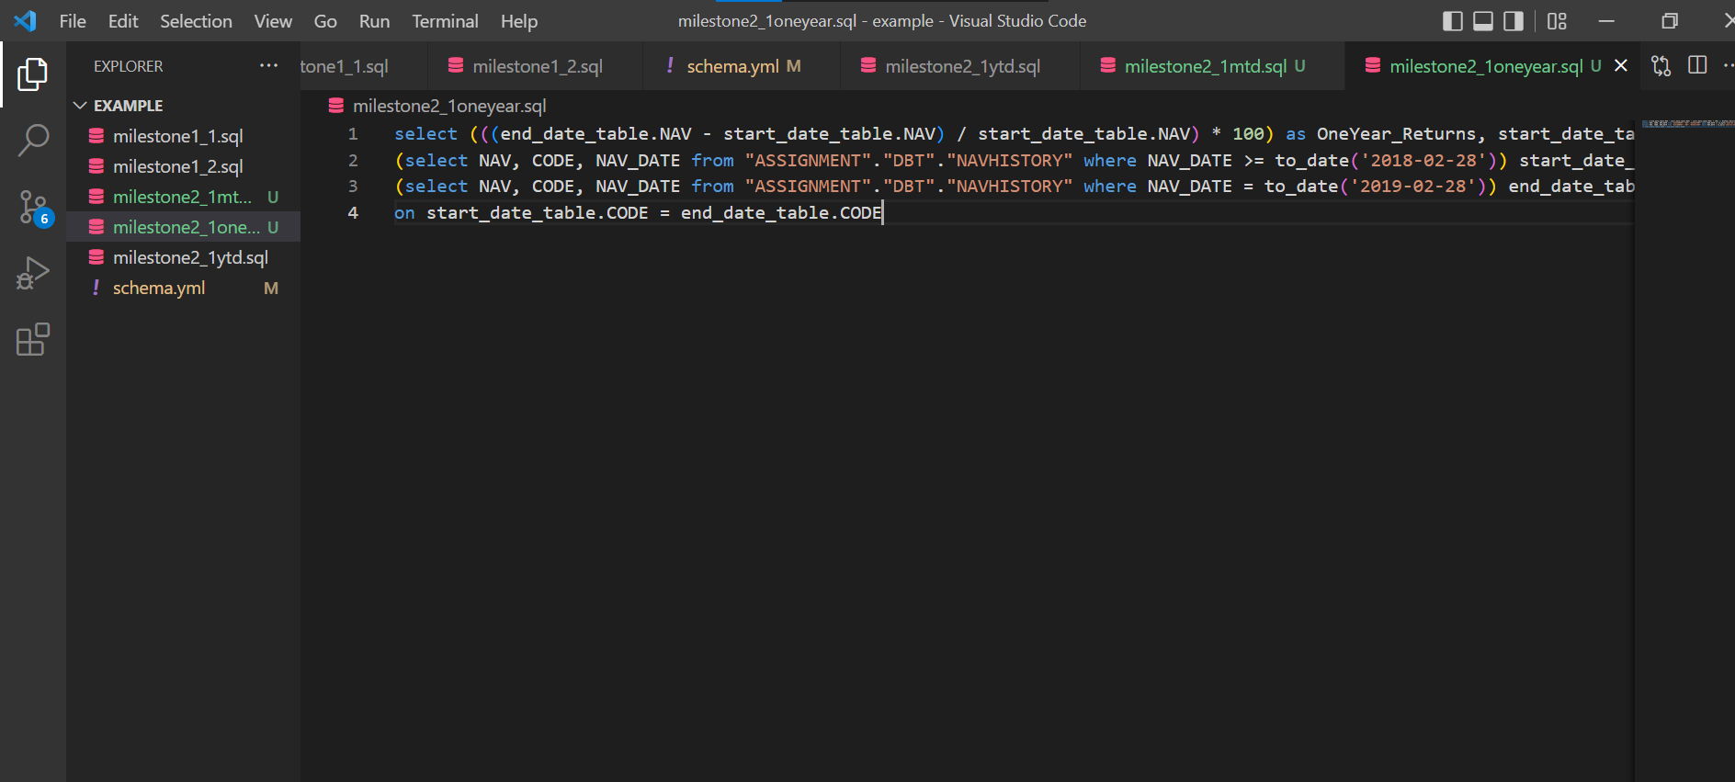

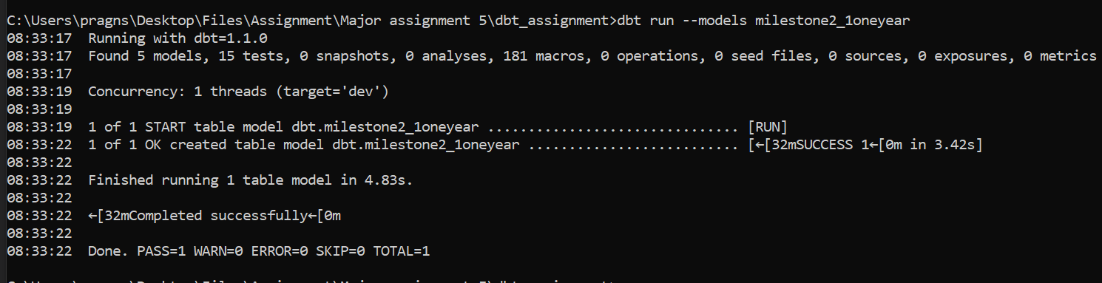

**4.**

Weekly, monthly and ytd results for all funds in liquid fund category

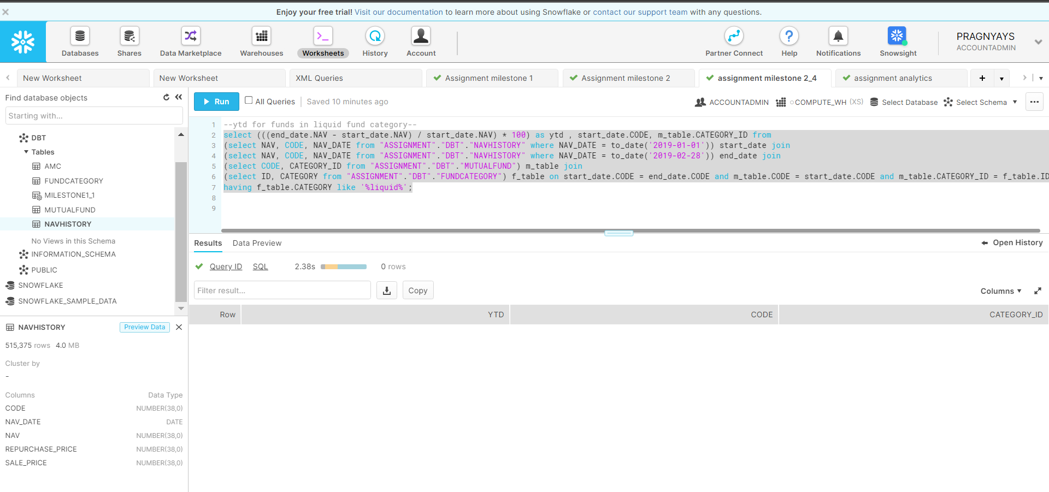

**MILESTONE 3**

**1.**

Plot performance of upto 3 funds for the past 3 months. [line]

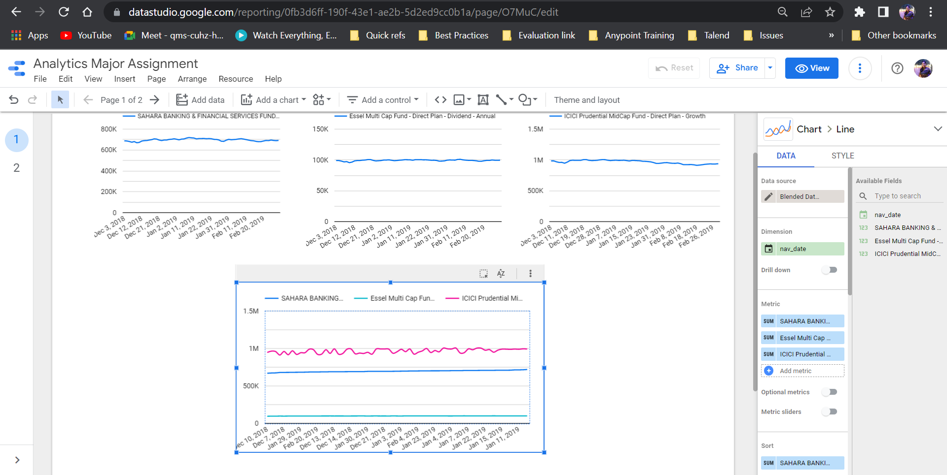

**3.**

Distribution of latest mutual funds based on category. [pie]

